# CS 255 System Design Document Template

## UML Diagrams

### UML Use Case Diagram

The use case diagram shows the functionality of the system from the user’s point of view. Based on the feedback presented on my original diagram, I’ve added all user roles and most of the system’s functionality. There are some things missing that I’d have like to included, but LucidChart enforces a limit on the amount of items you can place.

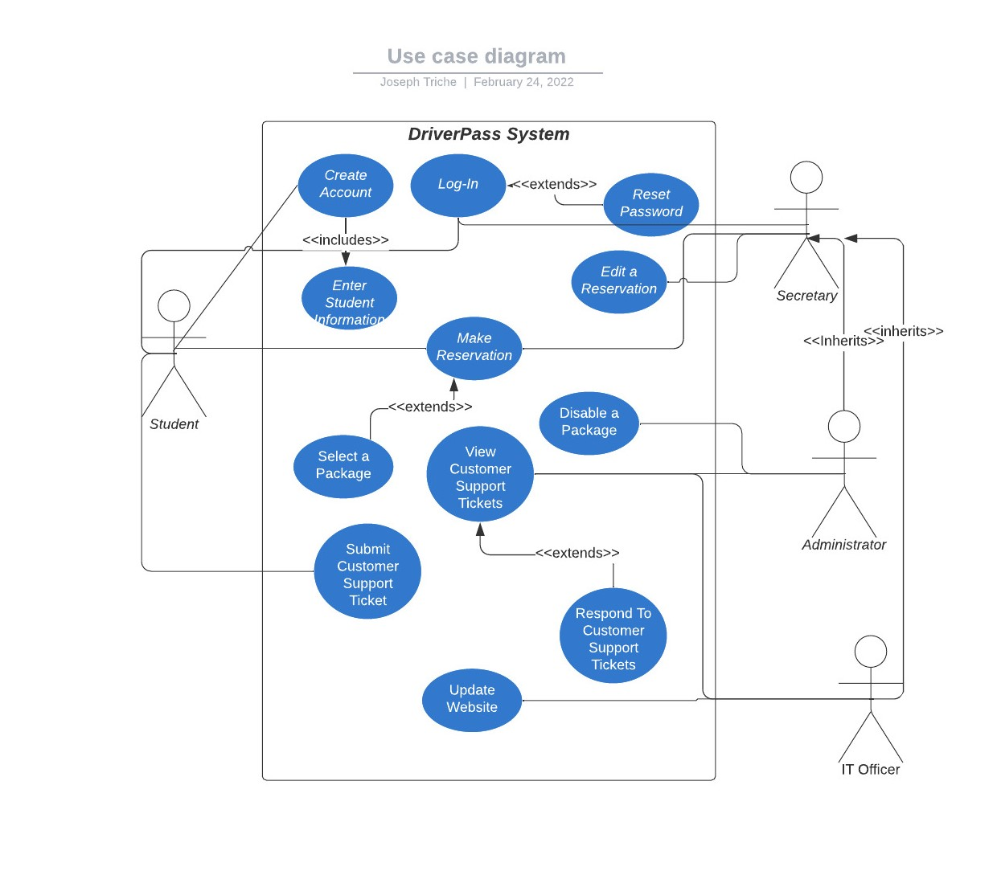

### UML Activity Diagrams

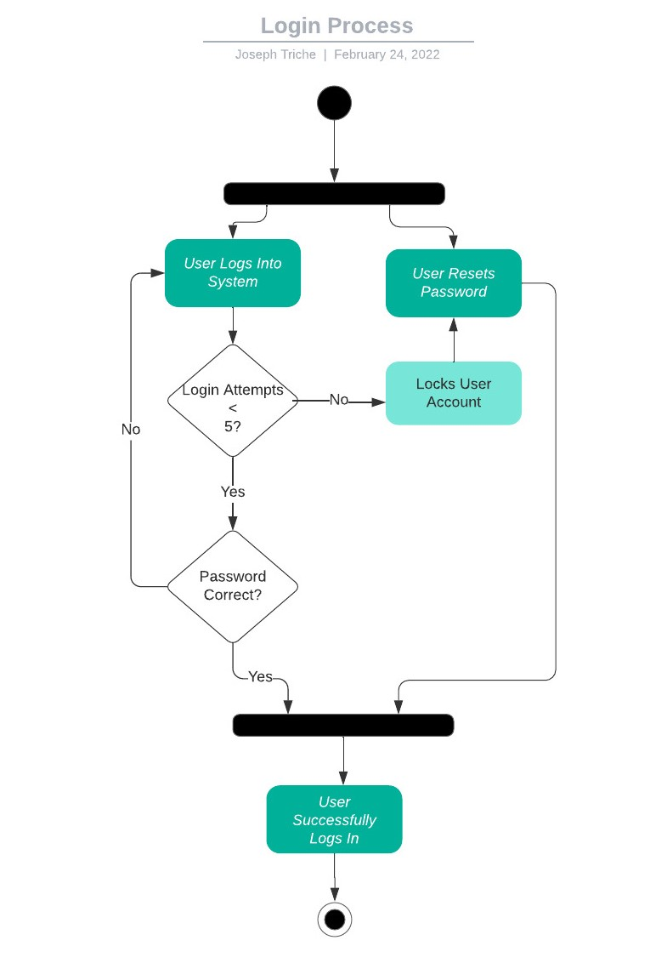

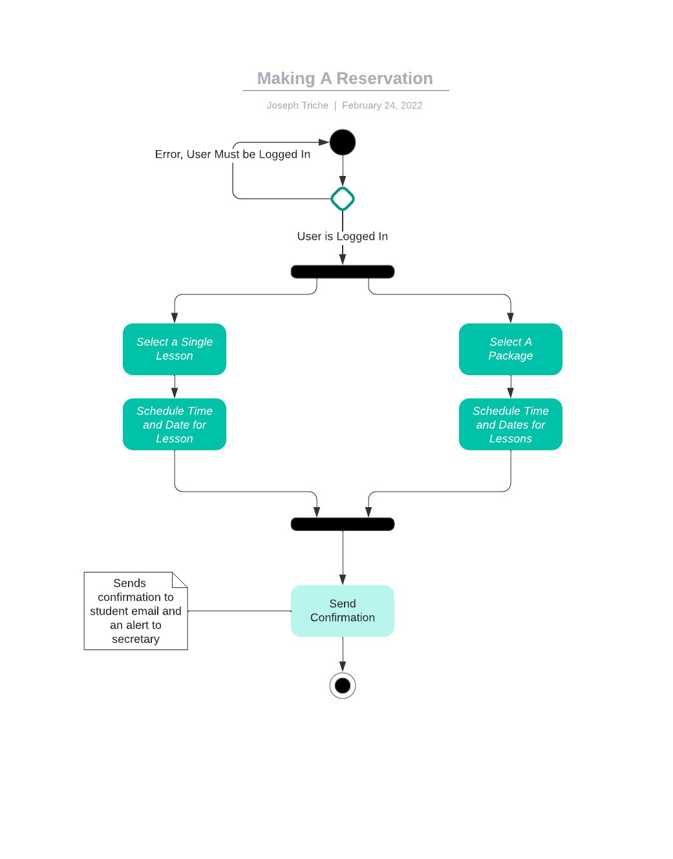

### UML Sequence Diagram

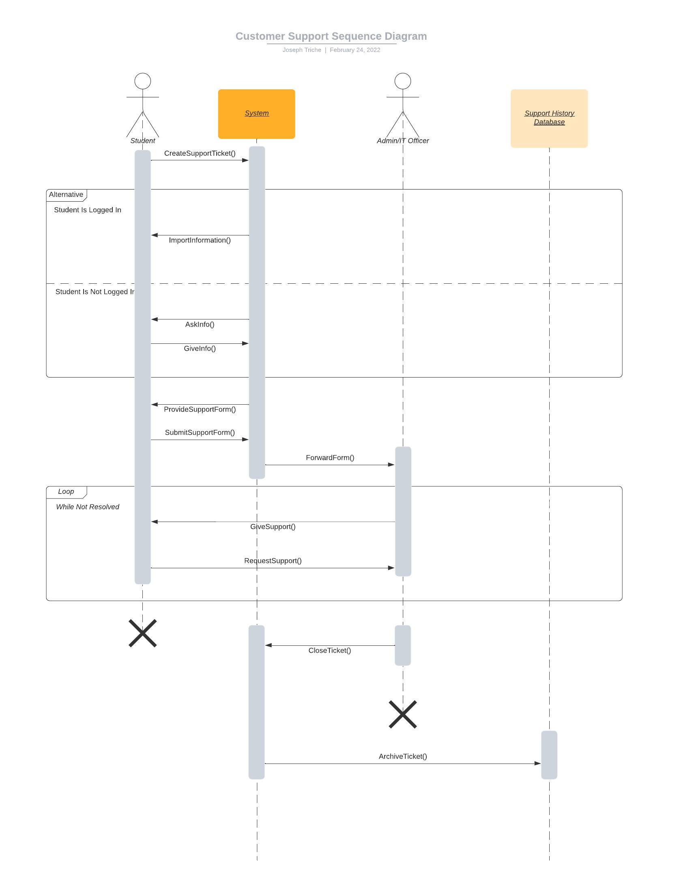

### UML Class Diagram

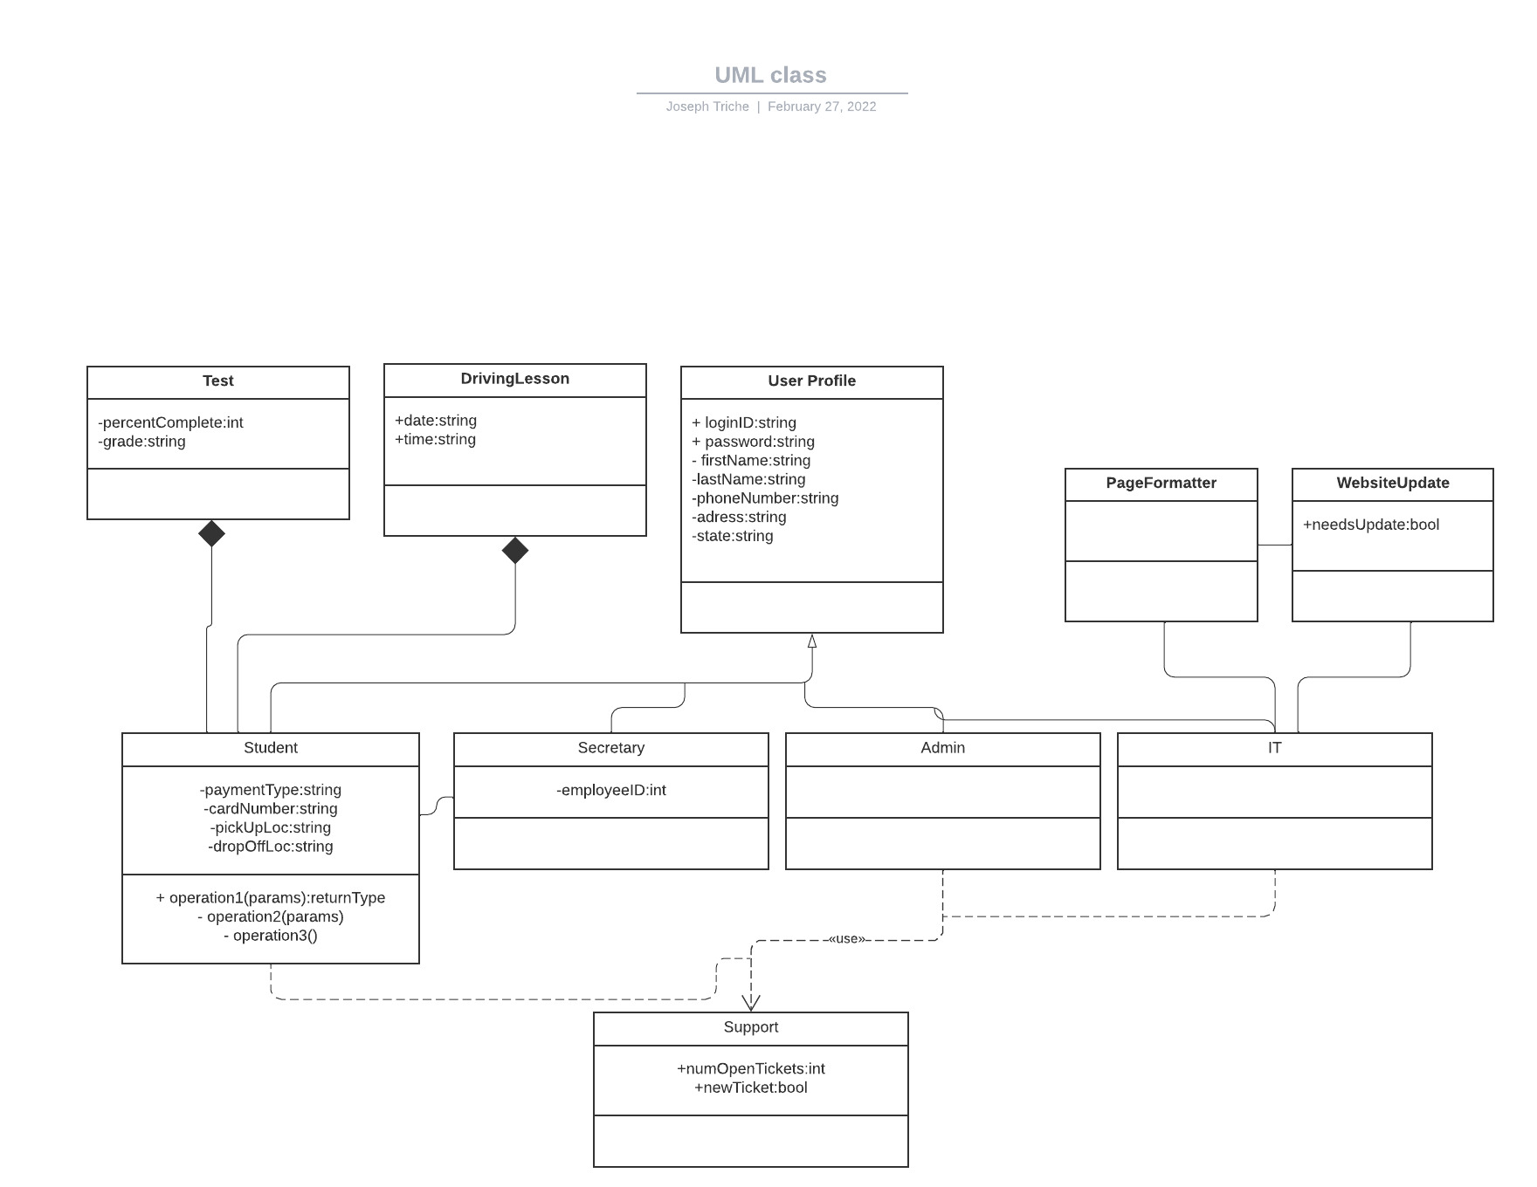

## Technical Requirements

* Must run on Windows, Apple, and Mobile
* Cloud-based
* Monitor, Mouse, Keyboard